SURVEY

Dear Participant,

Please complete this survey on a relevant public policy issue. The survey is anonymous, and no one will know what answers you give. This brief survey should take no more than 10 minutes to complete. Thank you for your time and help with this effort.
Sincerely,
Dr. Shahzeen Attari
Indiana University Bloomington

{Page Break}

What is the single most effective thing you currently do to save energy in your life? {Text Box}
_______________________________________________________

What is the single most effective thing you could be doing to save energy in your life? {Text Box}

_______________________________________________________

{Page Break}

During this survey, please keep the infographic below in mind. Incandescent light bulbs are less energy efficient than CFL (compact fluorescent light) bulbs, and CFL bulbs are less energy efficient than LED (light emitting diode) bulbs.
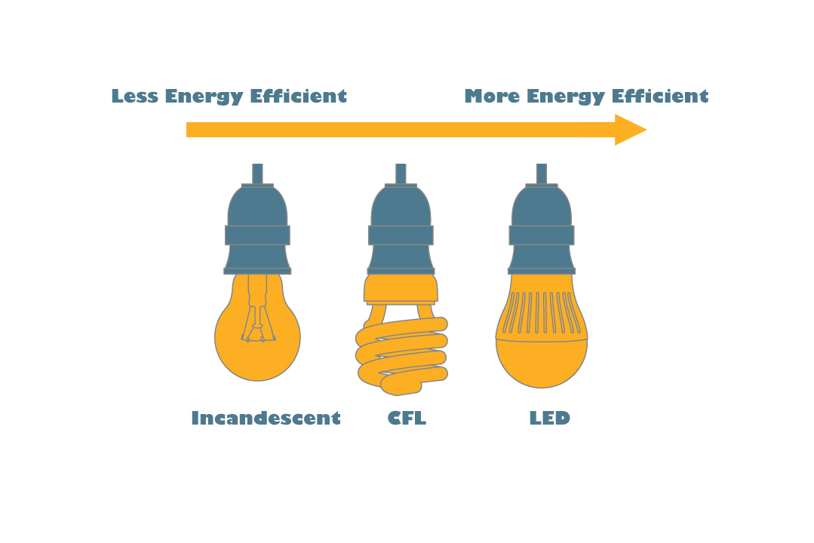

(Page Break)
Assume a friend of yours wants to know which of the two actions below saves the most energy over the course of a month. Which one would you tell them saves the most energy?

Always turning off the lights when leaving a room | Replacing incandescent light bulbs with more efficient light bulbs, like CFL and LED bulbs

(Page Break)

How did you choose your previous answer?
As a reminder, you were telling a friend which option saves the most energy over the course of a month: turning off the lights or replacing incandescent light bulbs with more efficient light bulbs.
________________________________________________________________________________________________________________________________________________________________________________________________________________________________________________________________________________________________________________________________________________________________

{Page Break}
{randomized; efficiency attribute section and curtailment attribute section appear in different orders equally}

Now think about the action of turning off the lights.

Please state how strongly you agree or disagree with each statement below.
 | Strongly Agree | Agree | Neutral | Disagree | Strongly Disagree
This is easy to do
This saves me money on my electricity bill
I am able to do this where I live
I was taught to do this
This is my habit
This helps the environment
This will make my light bulbs last longer
This significantly reduces my carbon footprint
Everyone else does this, so I do it too
I do this because of public advocacy (advertisements, media, etc.)

{Page Break}

Continue thinking about the action of turning off the lights.

Please state how strongly you agree or disagree with each statement below.
 | Strongly Agree | Agree | Neutral | Disagree | Strongly Disagree
This will help future generations
This is logical to do
This is ethical to do
I will feel guilty if I do not do this
Doing this makes me feel good
This takes too long to do
Friends pressure me to do this
This is the most effective method I know to save energy
This requires too much effort
This will set a good example for people around me

{Page Break}

Now think about the action of replacing incandescent light bulbs with more efficient light bulbs, like CFL and LED bulbs.

Please state how strongly you agree or disagree with each statement below.

 | Strongly Agree | Agree | Neutral | Disagree | Strongly Disagree
This is easy to do
This saves me money on my electricity bill
I am able to do this where I live
I was taught to do this
This is my habit
This helps the environment
This will make my light bulbs last longer
This significantly reduces my carbon footprint
Everyone else does this, so I do it too
I do this because of public advocacy (advertisements, media, etc.)

{Page Break}

Continue thinking about the action of replacing incandescent light bulbs with more efficient light bulbs, like CFL and LED bulbs.

Please state how strongly you agree or disagree with each statement below.

 | Strongly Agree | Agree | Neutral | Disagree | Strongly Disagree
This will help future generations
This is logical to do
This is ethical to do
I will feel guilty if I do not do this
Doing this makes me feel good
This takes too long to do
Friends pressure me to do this
This is the most effective method I know to save energy
This requires too much effort
This will set a good example for people around me

{Page Break}
{A/B randomized}
For each question below, read the two options presented and choose the option that you think saves the most energy.

Decreasing one incandescent light bulb’s use from 4 hours to 3 hours | Using one LED light bulb for 4 hours instead of an incandescent light bulb
Reducing the use of a window air conditioning unit from 5 hours to 3 hours | Keeping a ceiling fan on for 5 hours instead of using a window air conditioning unit
Reducing the use of a dehumidifier from 10 hours to 5 hours | Purchasing a 20% more efficient dehumidifier and using it for 10 hours instead of using a standard dehumidifier
Decreasing the use of one CFL bulb from 2 hours to 1 hour | Using one LED bulb for 2 hours instead of a CFL bulb
Decreasing the use of one CFL bulb from 10 hours to 1 hour | Using one LED bulb for 10 hours instead of a CFL bulb
Reducing the use of a projector to watch movies from 10 hours to 9 hours a week | Using a smartphone for 10 hours a week to watch movies instead of a projector
Decreasing the use of a central air conditioning unit from 6 hours to 5 hours | Using a ceiling fan for 6 hours instead of a central air conditioning unit
Reducing the use of a space heater from 5 hours to 4 hours | Using an electric blanket for 5 hours instead of a space heater
Reducing the use of a desktop computer to play music from 10 hours to 5 hours | Using a stereo to play music for 10 hours instead of a desktop computer

{Page Break}

In general, do you believe that you can save more energy by: {randomized}
Reducing how often you use an appliance | Replacing an appliance with a more efficient model

{Page Break}
When you are the last person to leave a room with the lights turned on, how often do you turn off the lights?

Hardly ever
Not very often
Often
Always

{Page Break}
What percent of light bulbs at your current residence are energy-efficient, such as CFL or LED bulbs?

_________%
{text entry, % sign outside text box}

{Page Break}

The most frequent response to “What is the single most effective thing you could do to save energy?” has been “turning off the lights”. While turning off the lights does save some energy, many other actions have the potential to save a lot more energy.

With this in mind, why do you think people continue to list "turning off the lights" as the most effective energy saving action they could do? {Text Box}

________________________________________________________________________________________________________________________________________________________________________________________________________________________________________________

{Page Break}

Recently, you may have noticed that climate change has been getting some attention in the news.

Climate change refers to the idea that the world’s average temperature has been increasing over the past 150 years, may be increasing more in the future, and that the world’s climate may change as a result. What do you think? Do you think that climate change is happening?

Yes – Definitely
Yes – Probably
No – Probably
No – Definitely

{Page Break}

How important is the issue of climate change to you personally?

Very important
Somewhat important
Not too important
Not at all important

{Page Break}

{Page Break}
For each statement below, please indicate how strongly you agree or disagree with the statement:

 | Strongly Agree | Somewhat Agree | Neither agree nor disagree | Somewhat disagree | Strongly Disagree
We are approaching the limit of the number of people the earth can support
Humans have the right to modify the natural environment to suit their needs
When humans interfere with nature, it often produces disastrous consequences
Human ingenuity will ensure that we do NOT make the earth unlivable
Humans are severely abusing the environment
The earth has plenty of natural resources if we just learn how to develop them
Plants and animals have as much right as humans to exist
The balance of nature is strong enough to cope with the impacts of modern industrial nations

{Page Break}
For each statement below, please indicate how strongly you agree or disagree with the statement:

 | Strongly Agree | Somewhat Agree | Neither agree nor disagree | Somewhat disagree | Strongly Disagree
Despite our special abilities, humans are still subject to the laws of nature
Human destruction of the natural environment has been greatly exaggerated
The earth has only limited room and resources
Humans were meant to rule over the rest of nature
The balance of nature is very delicate and easily upset
Humans will eventually learn enough about how nature works to be able to control it
If things continue on their present course, we will soon experience a major ecological disaster

{Page Break}
{Open-Ended}
To answer the following questions, please enter whole numbers or decimals with no other text (not ranges or percent signs). | Guess (number value)
Imagine that we flip a fair coin 1,000 times. What is your best guess about how many times the coin would come up heads in 1,000 flips?
In the BIG BUCKS LOTTERY, the chance of winning a $10 prize is 1%. What is your best guess about how many people would win a $10 prize if 1000 people each buy a single ticket from BIG BUCKS?
In ACME PUBLISHING SWEEPSTAKES, the chance of winning a car is 1 in 1,000. What percent of tickets to ACME PUBLISHING SWEEPSTAKES win a car?
Out of 1,000 people in a small town 500 are members of a choir. Out of these 500 members in the choir 100 are men. Out of the 500 inhabitants that are not in the choir 300 are men. What is the probability that a randomly drawn man is a member of the choir? Please indicate the probability in percent.
Imagine we are throwing a five-sided die 50 times. On average, out of these 50 throws how many times would this five-sided die show an odd number (1, 3 or 5)?
Imagine we are throwing a loaded die (6 sides). The probability that the die shows a 6 is twice as high as the probability of each of the other numbers. On average, out of these 70 throws how many times would the die show the number 6?
In a forest 20% of mushrooms are red, 50% brown and 30% white. A red mushroom is poisonous with a probability of 20%. A mushroom that is not red is poisonous with a probability of 5%. What is the probability that a poisonous mushroom in the forest is red?

{Page Break}
What is the average monthly electricity bill (in $) for your household?

Under $20
About $20
About $40
About $60
About $80
About $100
About $120
About $200
Above $200
Do not know
Not applicable
I don’t pay my bill

{Page Break}
Do you rent your living space?
Yes or no

{Page Break}
How would you describe your political beliefs?

Very Liberal
Liberal
Slightly Liberal
Moderate
Slightly Conservative
Conservative
Very Conservative

What is your gender?

Male
Female
Other

What is your age? {Open-Ended}
___________

{Page Break}
Do you have any degrees in the physical sciences, math or engineering?

Yes
No

What is the highest level of education you have attained?

Some schooling, but no diploma or degree
High School diploma or GED
Some college
College degree
Some graduate school
Graduate degree and beyond

During 2017, what was your yearly household income before taxes? Your best estimate is fine.

None
< $20,000
$20,000 - $40,000
$40,000 - $80,000
$80,000 - $120,000
$120,000 - $200,000
> $200,000

What is your zip code? {Open-Ended}
___________

{Page Break}
{Open-Ended}
Do you have any additional thoughts or comments about the survey that you would like to share with us?

________________________________________________________________________________________________________________________________________________________________________________________________________________________________________________

