Supplemental Text for
Turning a coal state to a green state: Identifying themes of support
and opposition to decarbonize the energy system in the United States
Table of Contents

1. Demographic Variable Distributions and Climate Change Views 2
Table S1. Distribution of categorical demographic variables 2
Table S2. Descriptive statistics for continuous demographic variables 3
Table S3. Distribution of climate change variables 3
2. Participant Recruitment 4
Figure S1. Participant map 5
3. Political Party and Ideology 6
4. Energy Mix Estimates 7
Table S5. Actual energy mix calculation 7
Figure S2. Current and Future Energy Mix Estimates 9
5. Energy Source Direction by Political Party 10
Figure S3. Energy source direction by political party 10
Partisan Differences 11
Table S7 – S8. Energy source direction codes by political party for fossil fuels 13
Table S9 – S14: Energy source direction codes by political party for low-carbon sources 15
6. Energy Policy Support by Political Ideology 20
Partisan Differences 20
Table S15 - S16. Pro-fossil fuel policy: support vs opposition codes by political party 21
Table S17 – S20. Pro-low-low carbon policy: support vs opposition codes by political party 23
7. Analysis of Miniard et al. (2020) Data 27
8. References 29
9. Survey 30
10. Interview Protocol 34
11. Information Sheets for Participants 38
12. Codebook 40

1. Demographic Variable Distributions and Climate Change Views
Table S1 reports the distribution of participants for political party, political ideology, education, income, gender, and the type of area they live in. Table S2 reports the descripted statistics for age and the number of years participants lived in Indiana. Table S3 presents the distribution of participants for climate change variables including whether participants think climate change is happening and how important climate change is to them personally. Note that climate change questions were asked at the end of the interview rather than in the survey and may have resulted in social desirability effects.
Table S1. Participant percent distribution for categorical demographic variables.
Political Ideology | % | Political Party | % | Education | %
Very conservative | 6.3% | Republican | 43.8% | Less than high school | 0.0%
Conservative | 18.8% | Independent | 20.8% | Some high school | 6.3%
Slightly conservative | 10.4% | Democrat | 25.0% | HS diploma / GED | 33.3%
Moderate | 33.3% | Other | 10.4% | Some college | 20.8%
Slightly liberal | 8.3% |  |  | College degree | 25.0%
Liberal | 12.5% |  |  | Some graduate school | 4.2%
Very liberal | 8.3% |  |  | Graduate degree | 10.4%
Income | % | Gender | % | Area | %
Under $15,000 | 37.5% | Female | 50.0% | Urban | 33.3%
$15,000 - $29,999 | 29.2% | Male | 47.9% | Rural | 41.7%
$30,000 - $49,999 | 10.4% | Prefer not to say | 2.1% | Suburban | 25.0%
$50,000 - $100,000 | 12.5%
Over $100,000 | 2.1%
Rather not say | 8.3%

Table S2. Descriptive statistics for demographic variables.
Variable | Mean | Median | Scale | Range | St. error | Skew
Age (in years) | 51.8 | 53.0 | 18 – 86 | 18 – 86 | 2.31 | -0.12
Time living in Indiana (in years) | 37.8 | 35.0 | 4.5 – 78 | 4.5 – 78 | 2.92 | 0.27

Table S3. Descriptive statistics for climate change variables.
Climate Change Belief | % | Climate Change Importance | %
Yes, definitely happening | 68.8% | Very important | 56.3%
Yes, probably happening | 18.8% | Somewhat important | 31.3%
No, probably not happening | 8.3% | Not too important | 6.3%
No, definitely not happening | 4.2% | Not at all important | 4.2%
 |  | No response | 2.1%

2. Participant Recruitment
To ensure participant variation in political beliefs, counties were selected by identifying those that voted majority Democrat in the 2016 presidential election, and then selecting surrounding counties that voted majority Republican to control for geographic variation. Both urban and rural locations were selected by identifying the most urban location and the most rural location within each county and sampling along this spectrum from urban to rural. A map of participant’s zip codes can be found in the SI text.
A list of public locations including libraries, parks, churches, fairs, public events, festivals, shopping centers, coffee shops, and laundromats were compiled for each county. These locations were contacted to request permission to recruit patrons who visited the public locations. Participants were recruited from 15 libraries, one church, one festival, and one shopping center. Recruiting on site was at the discretion of the owner or person in charge at each location. The general recruitment method was to set up a table at or near the entrance of the building or event and ask people as they entered if they would like to participate in a research study. Individuals who chose to participate were surveyed and interviewed on the spot in a quiet but public area.
Figure S1 shows a google map plot of participants’ ZIP codes. Participants were recruited from four counties that voted majority Democrat in the 2016 presidential election (Lake, Marion, Monroe, and St. Joseph), and surrounding counties that voted majority Republican (Brown, Elkhart, Greene, Lawrence, Marshall, Morgan, Newton).
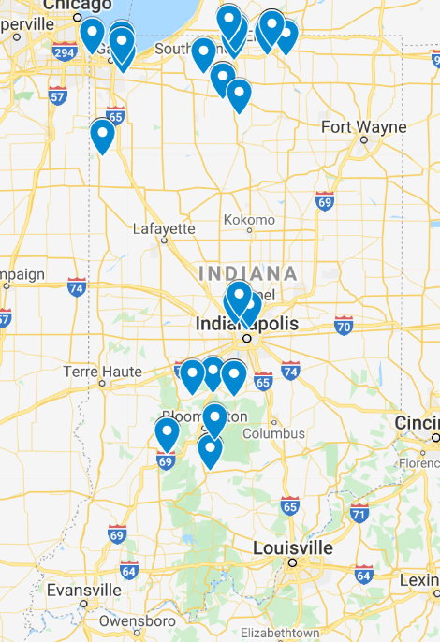
Figure S1. Map of participant (n = 48) ZIP codes. Note there are some cases where more than one participant resides in the same ZIP code which is represented by one blue point.

3. Political Party vs Political Ideology

Political differences will be analyzed by political party rather than political ideology in consideration that 10% of the sample does not have a valid measure of ideology. Political party is an appropriate variable to use as there has been a growing divide between Democrats and Republicans on environmental issues and climate change [1,2]. Moreover, studies have shown that partisan cues are stronger than ideological cues [3] and can even result in individuals supporting policies they would otherwise oppose when told their political party is in support [4,5].

Table S4. Number of participants for political party by political ideology
 | Conservative | Moderate | Liberal | No Response
Republican | 13 | 6 | 2 | 0
Independent/Other | 2 | 7 | 5 | 1
Democrat | 2 | 3 | 7 | 0

4. Energy Mix Estimates
Indiana Energy Mix Estimates by Source
Percentage estimates for the energy mix of Indiana were obtained using data from the United States Energy Information Administration (EIA) state energy data system [6]. I retrieved the csv data file for consumption measured in Btu for the years 1960 through 2017. The 2016 energy consumption estimates were the latest available consumption estimates; the 2017 estimates were not available for petroleum or renewable energy sources.
The data file contained energy consumption estimates for all 50 states between 1960 and 2017 for all energy sources across all energy sectors; however, not all data was available for 2017. The data file provides a total consumption variable for each energy source, which calculates energy consumption across all sectors. The total energy mix of Indiana was calculated based on the 2016 total energy consumption estimates for coal, natural gas, petroleum, biomass, wind, geothermal, hydroelectricity, solar, and nuclear. Table 1 reports consumption estimates by energy source for the state of Indiana, converted to trillion Btu. Consumption estimates were converted to percentages by dividing the consumption value for each energy source by the sum of all energy sources.
Table S5. Total consumption by energy source for Indiana in 2016.
Energy Source | Consumption in Trillion Btu | Percentage
Coal | 948.4 | 35.6 %
Natural gas | 779.9 | 29.2 %
Petroleum | 764.9 | 28.7 %
Biomass | 117.2 | 04.4 %
Wind | 45.2 | 01.7 %
Geothermal | 4.6 | 00.2 %
Hydroelectricity | 3.9 | 00.2 %
Solar | 2.4 | 00.1 %
Nuclear | 0 | 00.0 %

The EIA provides an appendix with descriptions for all energy consumption estimates and the formulas used to create energy consumption estimates [7]. Table 2 reports the sectors that are included in the total energy consumption estimates for each source, and how energy sources were defined when more than one energy resource is grouped together, as with petroleum and biomass.
Table S6. How EIA energy sources are grouped and calculated [7].
Energy Source | Description
Coal | Coal consumed by the following sectors: transportation, commercial, electric power, industrial, residential
Natural gas | Natural gas, excluding supplemental gaseous fuels, consumed by the following sectors: transportation, commercial, electric power, industrial, residential
Petroleum | Petroleum products including aviation gasoline, distillate fuel oil, hydrocarbon gas liquids, kerosene-type jet fuel, naphtha-type jet fuel, kerosene, motor gasoline (excluding fuel ethanol blended into motor gasoline), petroleum coke, residual fuel oil, and other petroleum products, consumed in the following sectors: transportation, commercial, electric power, industry, residential
Biomass | Biomass includes energy losses and co-products from the production of fuel ethanol, fuel ethanol (excluding denaturant), wood products, and waste products in the following sectors: commercial, electric power, industry, residential
Wind | Wind energy consumed by the following sectors: commercial, electric power, industrial
Geothermal | Geothermal energy consumed by the following sectors: commercial, electric power, industrial, residential
Hydroelectricity | Hydropower consumed by the following sectors: commercial, electric power, industrial
Solar | Solar energy consumed by the following sectors: commercial, electric power, industrial, residential
Nuclear | Nuclear energy consumed for electricity generation by the electric power sector

Current and Future Energy Mix Estimates

Figure S2 reports participants’ perceptions of the current state energy mix and preferences for the future energy mix broken down by political affiliation. Nineteen participants provided current energy mix estimates that did not total to 100% (17 participants for the future mix). To address this issue, energy estimates for each energy sources were proportionally scaled such that the sum of all nine energy sources for both the current and future energy mix equals 100 by participant.

Participants on average prefer using less fossil fuels, more renewable energy sources, and little to no nuclear energy for the state energy mix in 2050. Overall, participants preferred a future which relied primarily on renewable energy sources, particularly wind and solar, and less on fossil fuel resources. This pattern was observed for Democrats, Republicans, and Independents alike.
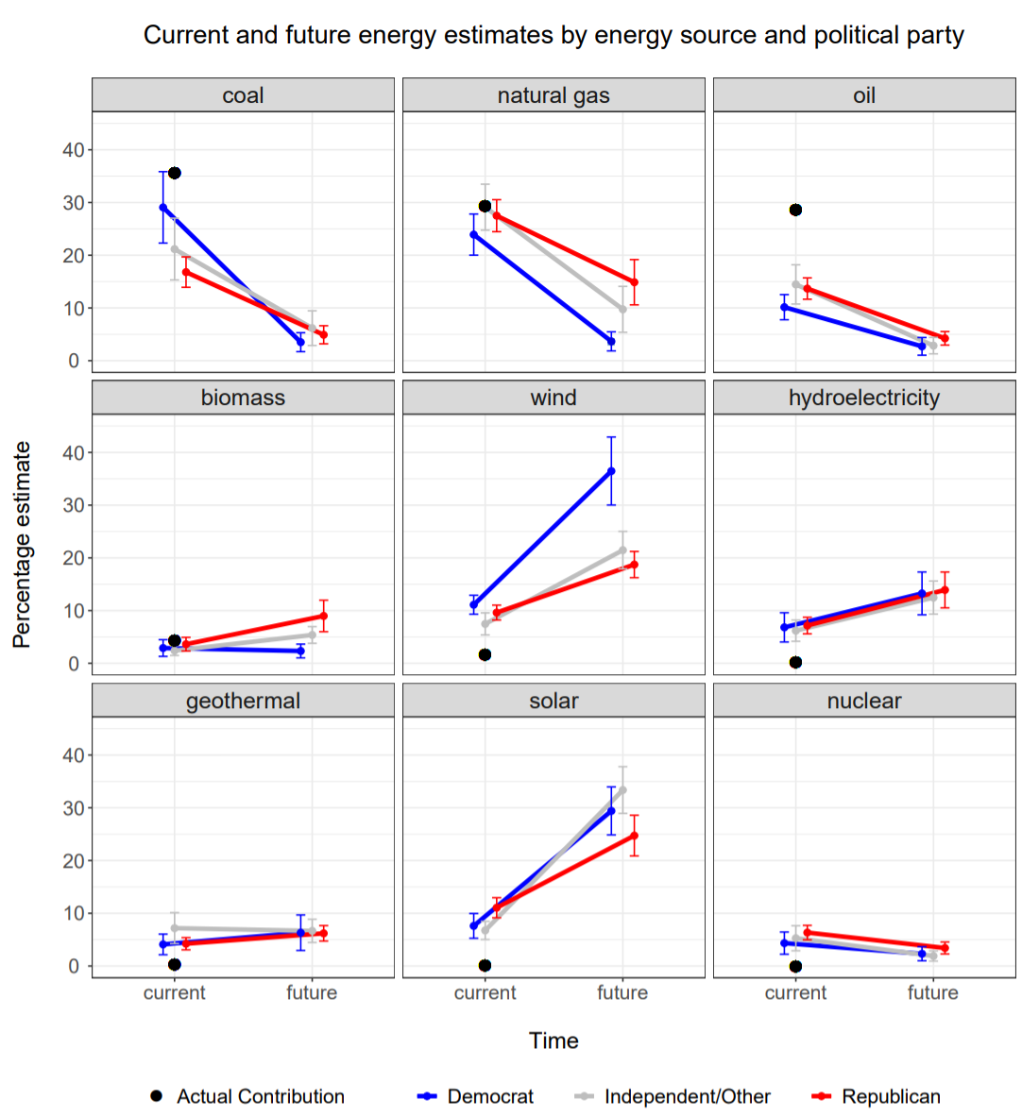

Figure S2. Mean current (2016) and future (the year 2050) energy estimates by political party affiliation (n = 47). Solid black dots represent the actual contribution of each energy source in the state of Indiana as of 2016 [6]. The energy sources are in descending order by actual percent contribution to the current energy mix starting with the highest contributing energy resource. Error bars indicate the 95% confidence interval.

5. Energy Source Direction by Political Party

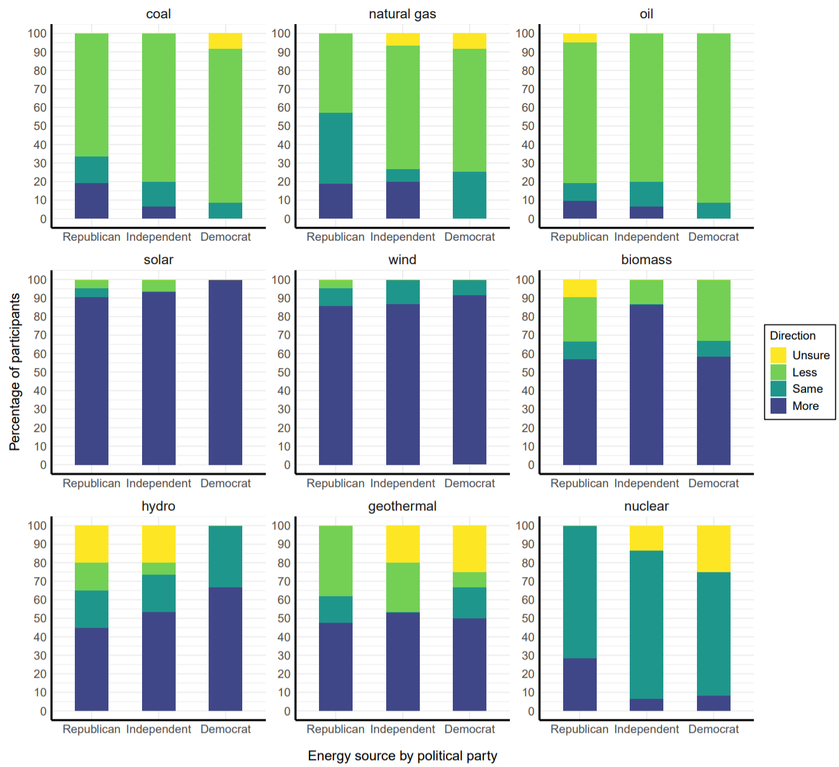
5a. Energy Source Direction – more, less, or same amount
Figure S3. Percentage of participants who want to use more, less, or the same amount of each energy source or were unsure broken down by political party affiliation. Note because nuclear energy is not used in Indiana, more indicates wanting to use nuclear and same amount indicates not wanting to use nuclear energy.

5b. Partisan Differences
Fossil Fuel Resources

Environmental concern, air quality, and public health were shared themes among all three political parties to decrease the use of fossil fuels. Political party differences emerged for climate change, coal workers, cost, foreign relations, and availability. Climate change was mentioned only by Democrats and Independents. Three Democrats and two Independents discussed climate change as a concern but only in reference to using less coal, and one Independent discussed climate change in reference to using less oil. In contrast, six Republicans and three Independents noted a concern for coal workers whereas only one Democrat referenced coal jobs. For natural gas, Republicans and Independents were concerned with cost, noting that natural gas was an expensive resource, whereas more Democrats described wanting less natural gas because it was a finite resource and would prefer to use renewable energy sources instead. In reference to oil, Republicans and Independents described foreign and international relations as a reason to use less oil, noting concerns about buying oil from other countries in the Middle East which may lead to political conflict.

No Democrats in the sample reported wanting to use more fossil fuel resources in Indiana. The desire to use more coal was primarily driven by Republicans who perceived coal to be a low-cost energy resource and wanted to keep or expand on coal jobs. Four Republicans and three Independents also wanted to see an increase in natural gas, describing it as a low-cost and available resource which should not be wasted. Finally, two Republicans supported an increase in oil to achieve energy independence.

Solar and Wind

The percentage of Republicans and Independents who wanted to use more wind and solar was slightly lower than that of Democrats, although these differences are minor (see Figure S3). The perception of solar and wind as always available, free or low-cost, and environmentally friendly were themes that emerged for Republicans, Democrats, and Independents alike.

Biomass, Hydro, & Geothermal

Republicans and Independents who wanted to use more biomass were primarily concerned with avoiding wasting resources that are readily available. Democrats reported a wide range of reasons for using more biomass; of all the reasons described by Democrats, the only theme that emerged for more than one participant was the comparison of biomass as being similar to other renewable resources. The perception of hydroelectricity as low-cost, natural, and available was consistent across all three political groups for those who wanted to use more hydroelectricity. The perception of geothermal as a natural resource which is good for the environment and relying on personal experience was shared among political groups as well.

Republicans, Democrats, and Independents agreed on the reasons to use less biomass as well, noting concerns for the environment, pollution, and air quality. Similarly, all political groups reported wanting less or the same amount of hydroelectricity because they did not think enough water resources were available or were concerned about environmental harm. Finally, perceptions of geothermal as dangerous or potentially harmful to the environment were shared among political groups.

Nuclear

More Republicans reported wanting to use nuclear energy than Independents or Democrats (Figure S3 in SI text). Concern about the risk that nuclear entails, examples of previous nuclear accidents, and a concern for public health were common themes across all political groups for those who did not want to use nuclear energy. Six Republicans (29%) described wanting to use nuclear energy because it was a low-cost energy source, cleaner than coal, safe, efficient, and would reduce fossil fuel use. Only one Independent and one Democrat wanted to use nuclear energy. The Democrat participant did not provide substantive reasons but the Independent noted nuclear as a cleaner energy source while citing a concern for risks and a desire not to have nuclear placed near their home.

5c. Energy Source Direction – codes for more verses less by political party
Fossil Fuels: Reasons for using more versus less fossil fuel resources broken down by energy source and political party affiliation.
Table S7. Top five codes for using less coal, natural gas, and oil, presented by political party.
Republican |  | Independent / Other |  | Democrat
Coal
N = 14 |  | N = 12 |  | N = 10
environmental harm, pollution | 50% | environmental harm, pollution | 58% | air quality harm | 40%
air quality harm | 43% | air quality harm | 42% | climate change, global warming | 30%
detrimental to public health, quality of life | 43% | coal jobs, workers | 17% | environmental harm, pollution | 30%
coal jobs, workers | 21% | climate change, global warming | 17% | detrimental to public health, quality of life | 20%
provide anecdote or example | 21% | detrimental to public health, quality of life | 17% | future legacy | 20%
comparison of resources | 21% | finite resource, nonrenewable | 17%
 |  | provide anecdote or example | 17%
Natural gas
N = 8 |  | N = 10 |  | N = 8
environmental harm, pollution | 50% | environmental harm, pollution | 50% | finite resource, nonrenewable | 38%
expensive, high-cost | 25% | fear, risk, danger, accident | 40% | environmental harm, pollution | 25%
fear, risk, danger, accident | 13% | comparison of resources | 40% | increase renewable use | 25%
aesthetics, space | 13% | expensive, high-cost | 30%
provide anecdote or example | 13%
Oil
N = 16 |  | N = 12 |  | N = 11
environmental harm, pollution | 38% | environmental harm, pollution | 83% | environmental harm, pollution | 64%
protection of environment | 19% | foreign, international relations | 25% | comparison of resources | 18%
foreign, international relations | 19% | finite resource, nonrenewable | 25% | fear, risk, danger, accident | 18%
finite resource, nonrenewable | 13% | air quality harm | 17%
air quality harm | 13% | provide anecdote or example | 17%
fear, risk, danger, accident | 13% | comparison of resources | 17%
politics, political system | 13%
Table S8. Top five codes for using more coal, natural gas, and oil, presented by political party.
Republican |  | Independent / Other |  | Democrat
Coal
N = 4 |  | N = 1 |  | N = 0
coal jobs, workers | 50% | good affect | 100%
low-cost or free resource | 50% | status quo, no system change | 100%
provide anecdote or example | 25%
Natural gas
N = 4 |  | N = 3 |  | N = 0
avoid being wasteful | 25.0% | clean or less dirty resource | 66.7%
low-cost or free resource | 25.0% | coal jobs, workers | 33.3%
clean or less dirty resource | 25.0% | low-cost or free resource | 33.3%
fossil fuel as transition resource | 25.0% | positive economic impacts | 33.3%
comparison of resources | 25.0% | available | 33.3%
 |  | renewable | 33.3%
 |  | provide anecdote or example | 33.3%
Oil
N = 2 |  | N = 1 |  | N = 0
positive economic impacts | 50% | status quo, no system change | 100%
energy independence | 50% | comparison of resources | 100%
foreign, international relations | 50%
misconception | 50%

Low Carbon Sources: Reasons for using more versus less low carbon resources broken down by energy source and political party affiliation
Solar and wind
Table S9. Top five codes for using more solar and wind presented by political party.
Republican |  | Independent / Other |  | Democrat
Solar
N = 19 |  | N = 14 |  | N = 12
available | 42% | low-cost or free resource | 50% | protection of environment | 50%
low-cost or free resource | 21% | available | 50% | available | 42%
natural resource | 21% | comparison of resources | 43% | low-cost or free resource | 25%
aesthetics, space | 21% | clean or less dirty resource | 21% | renewable | 17%
clean or less dirty resource | 16% | protection of the environment | 14% | doubt efficiency, reliability, feasibility | 17%
protection of environment | 16% | natural resource | 14% | provide anecdote or example | 17%
positive economic impacts | 16% | provide anecdote or example | 14% | comparison of resources | 17%
Wind
N = 18 |  | *N = 13 |  | N = 11
available | 39% | low-cost or free resource | 46% | natural resource | 36%
provide anecdote or example | 39% | doubt efficiency, reliability, feasibility | 23% | low-cost or free resource | 27%
air quality protection | 28% | provide anecdote or example | 15% | available | 27%
protection of environment | 28% | protection of environment | 15% | efficient, reliable, feasible | 18%
clean, less dirty | 22% |  |  | provide anecdote or example | 18%

Table S10. Top five codes for using less solar and wind presented by political party.
Republican |  | Independent / Other |  | Democrat
Solar
N = 1 |  | N = 1 |  | N = 0
doubt efficiency, reliability, feasibility | 100% | ozone | 100%
comparison of resources | 100%
misconception | 100%
Wind
N = 1 |  | N = 0 |  | N = 0
wildlife, species protection | 100%

Biomass, hydro, and geothermal
Table S11. Top five codes for using more biomass, hydroelectricity, and geothermal by political party.
Republican |  | Independent / Other |  | Democrat
Biomass
*N = 12 |  | *N = 13 |  | *N = 6
avoid being wasteful | 42% | avoid being wasteful | 31% | comparison of resources | 33%
unfamiliar, unknown | 33% | available | 15%
available | 25% | renewable | 15%
provide anecdote or example | 25% | unfamiliar, unknown | 15%
Hydroelectricity
N = 9 |  | *N = 8 |  | N = 8
available | 44% | available | 38% | low-cost or free resource | 38%
doubt efficiency, reliability, feasibility | 33% | low-cost or free resource | 25% | natural resource | 38%
provide anecdote or example | 33% | protection of environment | 25% | available | 38%
natural resource | 22% | unfamiliar, unknown | 25% | environmental harm, pollution | 25%
unfamiliar, unknown | 22% | provide anecdote or example | 25% | avoid being wasteful | 25%
 |  |  |  | provide anecdote or example | 25%
Geothermal
*N = 10 |  | *N = 8 |  | *N = 6
unfamiliar, unknown | 30% | provide anecdote or example | 63% | unfamiliar, unknown | 67%
low-cost or free resource | 20% |  |  | comparison of resources | 33%
protection of environment | 20%
provide anecdote or example | 20%

Table S12. Top five codes for using less biomass, hydroelectricity, and geothermal by political party.
Republican |  | Independent / Other |  | Democrat
Biomass
N = 5 |  | N = 2 |  | *N = 5
comparison of resources | 40% | environmental harm, pollution | 50% | air quality harm | 60%
avoid being wasteful | 20% |  |  | environmental harm, pollution | 60%
air quality harm | 20% |  |  | unfamiliar, unknown | 40%
environmental harm, pollution | 20%
aesthetics, space | 20%
Hydroelectricity
N = 2 |  | N = 1 |  | N = 0
doubt efficiency, reliability, feasibility | 100% | environmental harm, pollution | 100%
finite resource, nonrenewable | 50% | doubt efficiency, reliability, feasibility | 100%
comparison of resources | 50%
Geothermal
N = 8 |  | N = 4 |  | N = 1
fear, risk, danger, accident | 38% | fear, risk, danger, accident | 100% | unfamiliar, unknown | 100%
provide anecdote or example | 25% | misconception | 50% | comparison of resources | 100%
clean or less dirty resource | 13% | environmental harm, pollution | 50%
protection of environment | 13%
doubt efficiency, reliability, feasibility | 13%
misconception | 13%

Nuclear
Table S13. Top five codes for using nuclear presented by political party.
Republican |  | Independent / Other |  | Democrat
Nuclear
N = 6 |  | N = 1 |  | N = 1
low-cost or free resource | 33% | clean or less dirty resource | 100%
clean or less dirty resource | 33% | fear, risk, danger, accident | 100%
efficient, reliable, feasible | 33% | Nimby | 100%
safety, safe resource | 17% | available | 100%
reduce fossil fuel use | 17% | provide anecdote or example | 100%
 |  | comparison of resources | 100%

Table S14. Top five codes for not using nuclear presented by political party.
Republican |  | Independent / Other |  | Democrat
Nuclear
*N = 15 |  | N = 12 |  | N = 8
fear, risk, danger, accident | 87% | fear, risk, danger, accident | 92% | fear, risk, danger, accident | 88%
detrimental to public health, quality of life | 33% | provide anecdote or example | 42% | provide anecdote or example | 38%
provide anecdote or example | 20% | environmental harm, pollution | 25% | detrimental to public health, quality of life | 25%
wildlife, species protection | 13% | wildlife, species protection | 8% | comparison of resources | 25%
 |  | Nimby | 8% | dichotomy- environment vs economy | 13%
 |  | comparison of resources | 8% | safety, safe resource | 13%
 |  |  |  | misconception | 13%

6. Policy Support and Opposition by Political Party
6a. Partisan Differences
Pro-Fossil Fuel Energy Policy
Nine Republicans (43%) supported building new coal-fired power plants compared to three Independents (20%) and two Democrats (17%). All three political parties were motivated by a desire to protect coal jobs and coal workers. Republicans and Independents also identified this policy as reducing energy costs and having positive economic impacts on the state by leading to an increase in the use of coal mined in Indiana. In contrast, 11 Republicans opposed this policy (52%) as compared to 10 Independents (67%) and 10 Democrats (83%). Concerns about pollution, environmental harm, and public health were the top concerns among all three political parties. Democrats referenced climate change, a desire for more renewable energy sources, and a fear of continued coal use.

Six Republicans (29%) supported relaxing environmental regulations on oil and natural gas drilling to help the economy by reducing costs on fossil fuels and creating jobs, captured succinctly by [P2, R], “Jobs. And cheap energy.” The two Democrats (17%) in support did not provide substantive reasons. Independent’s support (20%) was driven by wanting to balance environmental and economic concerns, noting that fossil fuels may have negative environmental impacts but are necessary [P5, I/O], “Because even though I'm concerned about the environment, I think there needs to be at times a balance between what’s good for, you know, the worker and what’s good for the environment.” Concern for environmental harm, pollution, and the risk associated with drilling for oil and natural gas was shared among all three political parties. Democrats were the only group to describe climate change as a driver for opposition.

Pro-Low Carbon Energy Policy

The motivation to protect the environment, reduce pollution, and protect air quality was a shared theme across political parties. The primary difference was in the proportion of participants in each group who discussed each theme. Where Democrats were motivated by a desire to increase the use of renewable resources and address climate change, more Republicans mentioned economic impacts, fairness, or wanting to avoid wasting available resources.

6b. Policy support and opposition codes by political party
Pro Fossil Fuel Policies
Table S15. Top five codes for support or opposition to building new coal-fired power plants presented by political party.
Build new coal-fired power plants
Support
Republican |  | Independent / Other |  | Democrat
N = 9 |  | N = 3 |  | N = 2
coal jobs, workers | 56% | coal jobs, workers | 67% | coal jobs, workers | 50%
comparison of resources | 22% | low-cost or free resource | 33% | good affect | 50%
low-cost or free resource | 22% | positive economic impacts | 33%
Positive economic impacts | 22% | concern for those with low socioeconomic status | 33%
 |  | improve public health and quality of life | 33%
 |  | energy transition, energy future | 33%
Oppose
*N = 11 |  | N = 10 |  | N = 10
environmental harm, pollution | 45% | environmental harm, pollution | 40% | climate change, global warming | 30%
detrimental to public health, quality of life | 45% | detrimental to public health, quality of life | 30% | Increase renewable use | 30%
air quality harm | 27% | finite resource, nonrenewable | 30% | environmental harm, pollution | 20%
 |  | coal jobs, workers | 20% | fear, risk, danger, accidents | 20%
 |  | air quality harm | 20% | detrimental to public health, quality of life

Table S16. Top five codes for support or opposition towards relaxing regulations on oil and natural gas drilling presented by political party.
Relax regulations on oil and natural gas drilling
Support
Republican |  | Independent / Other |  | Democrat
*N = 6 |  | N = 3 |  | N = 2
positive economic impacts | 33% | comparison of resources | 33%
 |  | clean or less dirty resource | 33%
 |  | natural resource | 33%
 |  | environmental harm, pollution | 33%
 |  | dichotomy- environment vs economy | 33%
 |  | status quo, no system change | 33%
 |  | reduce fossil fuel use | 33%
Oppose
N = 13 |  | N = 12 |  | *N = 8
environmental harm, pollution | 38% | environmental harm, pollution | 67% | environmental harm, pollution | 63%
protection of environment | 23% | provide anecdote or example | 42% | fear, risk, danger, accident | 38%
fear, risk, danger, accident | 23% | business, vested interests, profits | 25% | climate change, global warming | 25%
regulatory control | 23% | fear, risk, danger, accident | 17% | increase renewable use | 25%
air quality harm | 15% | corruption of government or business | 17%
corruption of government or business | 15%

Pro Low-Carbon Policies
Table S17. Top five codes for support or opposition towards a renewable portfolio standard presented by political party.
Renewable Portfolio Standard
Support
Republican |  | Independent / Other |  | Democrat
*N = 18 |  | N = 14 |  | *N = 12
clean or less dirty resource | 39% | protection of environment | 50% | increase renewable use | 33%
protection of environment | 33% | low-cost or free resource | 29% | low-cost or free resource | 25%
air quality protection | 22% | air quality protection | 29% | protection of environment | 25%
available | 22% | improve public health and quality of life | 29% | energy transition, energy future | 25%
Oppose
N = 2 |  | N = 1 |  | N = 0
job impacts | 50% | natural resource | 100%
negative economic impacts | 50% | energy independence | 100%
business, vested interest, profits | 50%
increase fossil fuel use | 50%
increase renewable use | 50%
Table S18. Top five codes for support or opposition towards net metering presented by political party.
Net metering
Support
Republican |  | Independent / Other |  | Democrat
*N = 19 |  | N = 15 |  | *N = 10
positive economic impacts | 42% | fairness or lack of | 33% | incentive, market control | 60%
avoid being wasteful | 32% | positive economic impacts | 20% | avoid being wasteful | 20%
incentive, market control | 32% | business, vested interest, profits | 20% | corruption of government or business | 20%
business, vested interest, profits | 21% | incentive, market control | 20% | politics, political system | 20%
concern for those with low socioeconomic status | 21% | regulatory control | 20% | regulatory control | 20%
 |  |  |  | unfamiliar, unknown | 20%
Oppose
N = 1 |  | N = 0 |  | N = 1
fairness or lack of | 100% |  |  | fairness or lack of | 100%
business, vested interest, profits | 100% |  |  | business, vested interest, profits | 100%
 |  |  |  | corruption of government or business | 100%
 |  |  |  | concern for those with low socioeconomic status | 100%

Table S19. Top five codes for support or opposition towards a carbon fee presented by political party.
Carbon Tax
Support
Republican |  | Independent / Other |  | Democrat
*N = 13 |  | N = 9 |  | *N = 10
protection of environment | 31% | polluter accountability | 56% | polluter accountability | 60%
polluter accountability | 23% | protection of environment | 33% | incentive, market control | 40%
 |  | misconception | 22% | fairness or lack of | 20%
 |  | CO₂ as a pollutant | 22% | sacrifice, collective effort | 20%
 |  | Increase renewable use | 22%
Oppose
*N = 8 |  | *N = 6 |  | N = 0
politics, political system | 38% | expensive, high-cost | 50%
corruption of government, business | 100% | concern for those with low socioeconomic status | 50%
 |  | fairness or lack of | 33%
 |  | corruption of government, business | 33%

Table S20. Top five codes for support or opposition towards the Green New Deal presented by political party.
Green New Deal
Support
Republican |  | Independent / Other |  | Democrat
N = 15 |  | *N = 12 |  | *N = 10
protection of environment | 40% | environmental harm, pollution | 33% | climate change, global warming | 50%
air quality protection | 27% | protection of environment | 25% | improve public health and quality of life | 50%
good affect | 20% | CO2 as pollutant | 25% | extremity or extreme action/outcome | 30%
CO2 as pollutant | 13% | concern for those with low socioeconomic status | 25%
improve public health and quality of life | 13%
Oppose
*N = 6 |  | *N = 3 |  | N = 1
extremity or extreme action/outcome | 50% | coal jobs, workers | 33% | status quo, no system change | 100%
negative economic impacts | 33% | expensive, high-cost | 33% | concern for those with low socioeconomic status | 100%
politics, political system | 33% | job impacts | 33% | increase fossil fuel use | 100%
 |  | protection of environment | 33%
 |  | extremity or extreme action/outcome | 33%

7. Analysis of Miniard et al. (2020) Data
Miniard et al. [8] investigated perceptions of the current national energy mix and the energy mix people hoped for at the national level. They found that individuals across political ideology and political party hoped for a future energy mix that was decarbonized, though there were differences on the policy pathways to get there. We analyzed the Indiana (n = 47) subset of the national data collected from Miniard et al., (2020) to investigate whether similar patterns would emerge. Note that participants were responding for the desired national energy mix, not the state level energy mix.
The figure below shows Indiana residents’ perceptions of the current energy mix and the future energy mix participants hope for in the year 2050. We find similar results in this sample as we do in the present study. Participants underestimated the amount of fossil fuels (except for coal) and overestimate the amount of renewable energy resources we use at the national level. Additionally, participants hope for a future energy mix that relies primarily on renewable resources, particularly wind and solar, and drastically decreases fossil fuel consumption. Moreover, we see a slight decrease in the use of nuclear, and no changes on biomass, which are themes that emerged throughout interviews in the present study. Additionally, we do not see as large of an increase in the use of hydroelectricity or geothermal, which emerged in our interviews as well, with more participants being unsure of these resources due to lack of familiarity and questioning whether environmental harms or risks are associated with their use. Not shown here, but we see similar results if we analyze by political ideology instead of political party.
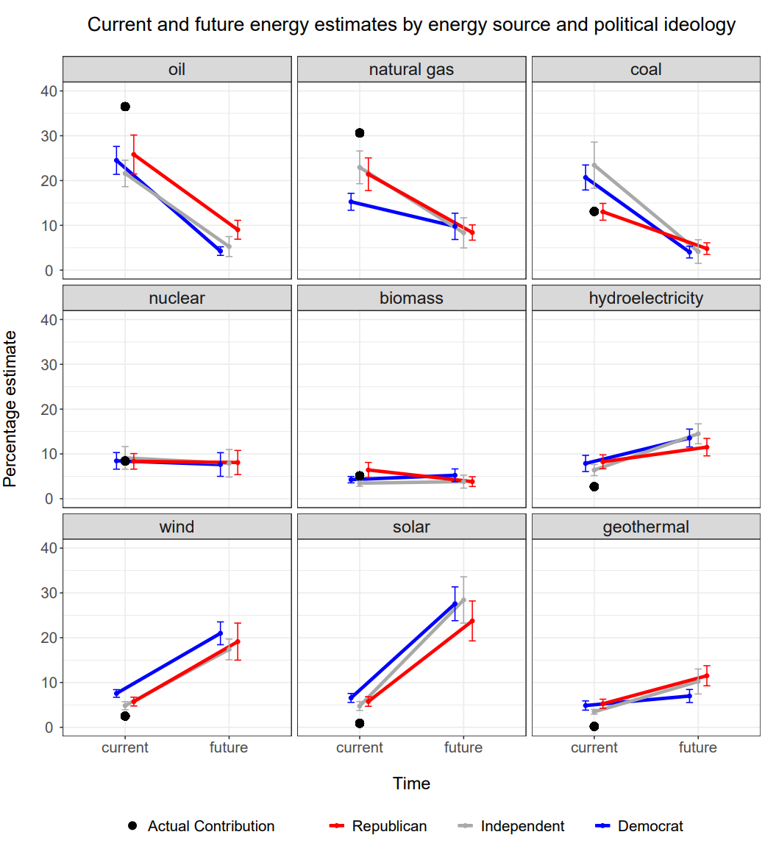
Figure S4. Mean current (2016) and future (the year 2050) energy estimates by political party affiliation for Indiana residents in the Miniard et al. [8] dataset (n = 47). Solid black dots represent the actual contribution of each energy source in the United States as of 2016. The energy sources are in descending order by actual percent contribution to the current energy mix starting with the highest contributing energy resource. Error bars indicate the 95% confidence interval.

8. References
[1] R. E. Dunlap, A.M. McCright, A widening gap: Republican and Democratic views on climate change, Environment: Science and Policy for Sustainable Development 50 (2008) 26–35, https://doi.org/10.3200/ENVT.50.5.26-35.
[2] A. M. McCright, R.E. Dunlap, The politicization of climate change and polarization in the American public’s Views of global warming, 2001–2010, The Sociological Quarterly. 52 (2011) 155–194, https://doi.org/10.1111/j.15338525.2011.01198.x.
[3] M. Barber, J.C. Pope, Does party trump ideology? Disentangling party and ideology in America, American Political Science Review. 113 (2019) 38 – 54, https://doi.org/10.1017/S0003055418000795.
[4] G.L. Cohen, Party over policy: The dominating impact of group influence on political beliefs, Journal of Personality and Social Psychology. 85 (2003) 808-822, https://doi.org/10.1037/0022-3514.85.5.808.
[5] J.N. Druckman, E. Peterson, R. Slothuus, R. How elite partisan polarization affects public opinion formation, American Political Science Review. 107 (2013) 57–79, https://doi.org/10.1017/S0003055412000500.
[6] U.S. Energy Information Administration (EIA). (2019). “Indiana SEDS”. Retrieved from https://www.eia.gov/state/seds/seds-data-fuel.php?sid=IN#DataFiles
[7] U.S. Energy Information Administration (EIA). (2017). Appendix A. Mnemonic Series Names (MSN). Retrieved from: https://www.eia.gov/state/seds/sep_fuel/notes/use_a.pdf
[8] D. Miniard, J. Kantenbacher, S.Z. Attari, Shared vision for a decarbonized future energy system in the United States, Proc. Natl. Acad. Sci. 117 (2020) 7108–7114. https://doi.org/10.1073/pnas.1920558117.

9. Survey

- In Indiana, we use energy for a variety of needs such as electricity, transportation, agriculture, industry, commercial, and heating. Our energy comes from a mix of many different sources. Some sources contribute a lot and other sources contribute only a little to our overall energy needs. The breakdown of those contributions is referred to as the energy mix.

What do you think is the current energy mix for the state of Indiana? In other words, out of the total energy consumed in Indiana, what percentage do you think is supplied by each energy source (e.g. out of 100%, what percentage comes from coal, what percentage comes from oil, and so on down the list)?

Energy Source | Percentage
Coal
Oil
Natural Gas
Nuclear
Wind
Solar
Hydroelectricity
Biomass
Geothermal

- Now I’m going to ask about your hopes for the future energy mix of Indiana. What do you think would be the absolute best possible energy mix for Indiana by the year 2050 (thirty years from now)? In other words, what percent of the total energy consumption in Indiana do you hope is supplied by each source in the year 2050 (e.g. out of 100%, what percentage do you hope comes from coal, what percentage do you hope comes from oil, and so on down the list)?

Energy Source | Percentage
Coal
Oil
Natural Gas
Nuclear
Wind
Solar
Hydroelectricity
Biomass
Geothermal

- How would you describe your political beliefs?

- Very conservative
- Conservative
- Slightly conservative
- Moderate
- Slightly liberal
- Liberal
- Very liberal

- Do you consider yourself to be a:

- Republican
- Democrat
- Independent
- Other: ______________________________

- What is your gender?

- Female
- Male
- Other
- Prefer not to say

- What is your annual household income, in US dollars?

- Under $15,000
- $15,000 - $29,999
- $30,000 - $49,999
- $50,000 - $100,000
- Over $100,000
- Rather not say

- What is your highest level of education?

- No school
- Less than high school
- Some high school
- High school diploma or GED
- Some college
- College degree
- Some graduate school
- Graduate degree

- What is your profession? _________________________________________

- What is your age? _______________

- How long have you lived in the state of Indiana? ___________________

- Which of the following best describes the area you live in?

- Urban
- Suburban
- Rural

- Do you have children?

- Yes
- No

- Do you have grandchildren?

- Yes
- No

- What is your ZIP code? ____________________
Thank you for your responses. Please place the survey in the brown envelope or return it back to the researcher.
10. Interview Protocol
Introduction

In this interview, I am going to ask you questions to understand what you think about the energy we use in Indiana. I will also ask you questions about policies that relate to the energy we use. I’d like to remind you that your answers are confidential. No identifying information will be collected. Do you have any questions for me?

Before we begin the interview, I’d like to ask you to take a short 3 to 5 minute survey. I have an information sheet which provides a brief explanation of different energy sources if one is unfamiliar to you. When you are finished, you can place the survey in this envelope, and we can begin the interview.

Introduction to Interview -- After Survey

Thank you for taking the survey. Now we can begin the interview. During this interview, I will be asking for your beliefs and opinions about energy and policies related to energy. There are no right or wrong answers. I simply want to know what you think.

Some of the items I ask about might be less familiar and you might hear terms that are new to you. If so, that’s okay! You can ask me questions at any time throughout the interview, and you can also ask me to repeat a question if you’d like to hear it again.

As a reminder, if you are unfamiliar with an energy source, please refer to the handout which provides a brief description of each energy source. Here is a second handout that shows how much of each energy source we use in the state of Indiana. (For example, this shows that out of all the energy we consume in the state of Indiana, 35.6% comes from coal).

Before we begin, do you have any questions for me?

Before we begin, do I have your consent to record this interview?

Warm Up Questions

- What do you want the future energy system of Indiana to be in 2050 (thirty years from now)? Could you describe it to me?

- Now think about future more broadly, outside of the energy system. What do you think the future is going to look like in 2050 (thirty years from now)? Could you describe it to me?

Perceptions of Energy Sources
Thank you for your responses. Now I am going to ask you questions about the energy sources we use in Indiana. I would like to remind you that you can refer back to those handouts at any time throughout the interview.

- In the state of Indiana, do you want to use more, less, or the same amount of [coal, biomass, natural gas, wind, oil]?
  - Probe 1: Can you say more about the reasons you want to use [more / less/ the same amount of] [energy source]?
  - Optional Probe 1: If participant responds “I don’t know”: What kinds of things would you like to know about [energy source] to help you decide?

Coal:
Biomass:
Natural Gas:
Wind:
Oil:
Solar:
Hydroelectricity:
Geothermal:

- Currently, the state of Indiana does not use nuclear energy. Do you want Indiana to use nuclear energy?
  - Probe 1: Can you say more about the reasons you [do / do not] want to use nuclear energy?
  - Probe 2: Why do you think we do not use nuclear energy in Indiana?
  - Optional Probe 1: If participant responds “I don’t know”: What kinds of things would you like to know about [energy source] to help you decide?

Support/Opposition to Decarbonization Policies
Thank you for your responses. Now I am going to ask what you think about policies related to energy in Indiana.

- Do you support or oppose building new coal-fired power plants to use coal that can be mined in Indiana?
  - Probe 1: Can you tell me about the reasons you [support / oppose]?
  - Optional Probe 1: If participant responds “I don’t know”: What kinds of things would you like to know to help you decide?

- For the state of Indiana, do you support or oppose requiring that a specified percentage of electricity comes from renewable energy resources?
  - Probe 1: Can you tell me about the reasons you [support / oppose]?
  - Optional Probe 1: If participant responds “I don’t know”: What kinds of things would you like to know to help you decide?
  - Probe 2: Currently Indiana has a goal of using 10% of renewable energy resources for electricity by 2025. Do you think this percentage should be lower, higher, or stay the same?
    - Probe 2.A: Can you tell me about the reasons you want it to be [lower / higher / the same]?

- Some people generate their own electricity, usually by placing solar panels on their roofs. Sometimes people generate more electricity than what they can use. The extra electricity can be sold to their utility company, in return for a credit on their electricity bill.
  - For Indiana, do you support or oppose allowing people who generate their own electricity to sell the extra electricity to their utility company?
    - Probe 1: Can you tell me about the reasons you [support / oppose]?
    - Optional Probe 1: If participant responds “I don’t know”: What kinds of things would you like to know to help you decide?
  - Probe 2: Do you support or oppose requiring that utility companies have to purchase the extra electricity produced?
    - Probe 2.A: Can you tell me about the reasons you [support / oppose]?

Now let’s focus on energy polices related to the United States.
- Do you support or oppose relaxing environmental regulations on oil and natural gas drilling in the United States?
  - Probe 1: Can you tell me about the reasons you [support / oppose]?
  - Optional Probe 1: If participant responds “I don’t know”: What kinds of things would you like to know to help you decide?

- Consider a carbon fee which places a price on the burning of fossil fuels such as oil, natural gas, and coal. This fee is based on how much carbon dioxide is emitted. The more carbon dioxide emitted, the higher the fee.
  - Do you support or oppose a national carbon fee for the United States?
    - Probe 1: Can you tell me about the reasons you [support / oppose]?
    - Probe 2: Would it change your [support / opposition] if consumers had to pay a higher price for electricity because of the fee?
    - Probe 3: What do you think the money collected through the fee should be used for?
  - Optional Probe 1: If participant responds “I don’t know”: What kinds of things would you like to know to help you decide?

- There is a new resolution people are discussing called the Green New Deal. The Green New Deal lays out a plan to address climate change in the United States. Have you heard about the Green New Deal?
  - Optional Probe 1: If participant responds “Yes”: What are your thoughts about the Green New Deal?
  - If participant responds “No”: Probe 1: One goal of the Green New Deal is to transition the United States to energy sources that do not emit carbon dioxide, by the year of 2050. Do you support or oppose this goal?
    - Probe 1.A: Can you tell me about the reasons you [support / oppose ]?
    - Optional Probe 1.B: If participant responds “I don’t know”: What kinds of things would you like to know to help you decide?
  - Probe 2: The Green New Deal has many additional goals. Other goals include creating jobs, investing in infrastructure and protecting vulnerable communities and populations such as the elderly, youth, & minorities. What do you think about these additional goals?

Climate Change Questions

- You may have noticed that climate change has been getting some attention in the news. Climate change refers to the idea that the world’s average temperature has been increasing over the past 150 years, may be increasing more in the future, and that the world’s climate may change as a result. What do you think? Do you think that climate change is happening?
  - Choices: Yes-Definitely, Yes-Probably, No-Probably, No-Definitely
  - Probe 1: Do you think the energy sources that are used in the United States do or do not contribute to climate change?

- How important is climate change to you personally?
  - Choices: Very important, somewhat important, not too important, not at all important
  - Probe 1: What other issues are important to you personally?
    - Probe 1.A: How do you think climate change will affect the issues you care about?
  - Probe 2: What might cause climate change to become more important to you?

Thank you for your responses and for participating in this study. Do you have any thoughts, comments, or insights you would like to share about the survey or about the interview?

Thank you again for your participation and your time.

11. Information Sheets for Participants

Energy Sources

Coal is a combustible rock with large amounts of carbon, and is created over millions of years. Coal is burned to produce heat and electricity.

Biomass is organic material from plants and animals that is burned to create energy or heat. Biomass includes energy sources such as wood, waste materials, landfill gas, and biofuels.

Natural gas is formed over millions of years and is comprised primarily of methane. Natural gas is burned to generate heat and electricity.

Wind is used to generate electricity using the kinetic energy collected by wind turbines. Wind turbines can be placed on land or off-shore in large bodies of water.

Oil is a fossil fuel made up of hydrocarbons, and is created over millions of years. Oil is used to create petroleum products such as gasoline, diesel fuel, and jet fuel.

Solar energy can be used two ways. One method is using photovoltaic panels to convert sunlight into energy. Another method uses solar thermal energy to heat water or homes and can be used to generate electricity.

Hydroelectricity is produced by moving water. Electricity is generated when a flowing body of water, such as a river, turns a turbine. Water in a reservoir created by a dam can be released as needed to generate electricity.

Geothermal energy comes from heat within the Earth produced by the decay of radioactive particles in the Earth’s core. This heat is used for heating and electricity generation.

Nuclear energy comes from the process of nuclear fission. In this process, atoms are split apart, which creates energy through heat and radiation. Uranium is most commonly used in this process.

Energy Sources by Consumption in the State of Indiana.

Energy Source | Percentage
Coal | 35.6 %
Natural Gas | 29.2 %
Oil | 28.7 %
Biomass | 4.4 %
Wind | 1.7 %
Geothermal | 0.2 %
Hydroelectricity | 0.1 %
Solar | 0.1 %
Nuclear | 0 %

12. Codes and Definitions
Table S21. Economic codes and code definitions.
Economy: macro and micro level aspects of the economy
Code | Definition
negative economic impacts | References negative effects on the economy or some aspect related to the economy in reference to the (1) economy as a whole, (2) economic effects on businesses, (3) economic effects on industry, (4) economic effects on the individual or consumer.
positive economic impacts | References positive effects on the economy or some aspect related to the economy in reference to the (1) economy as a whole, (2) economic effects on business, (4) economic effects on industry, (4) economic effects on the individual or consumer. References something as being profitable or having the potential to be profitable or benefit the economy or businesses.
low-cost or free resource | References that an energy source or some aspect of energy generation is low cost or cheap. References some aspect of energy \being low cost for consumers or helping consumers with their energy or electricity costs.
expensive, high-cost | References some aspect of energy or energy generation as being high-cost or expensive. References a policy or policy outcome as being high cost or expensive. References some aspect of energy being high cost for consumers or hindering people from affording their energy or electricity costs.
job impacts | References some aspect of jobs such as (1) job loss, (2) job creation, (3) job transition, (4) improving conditions for workers excluding specific references to loss coal jobs or coal workers.
avoid being wasteful | References not wanting to waste available resources or be wasteful with energy. References wanting to use what's already available.
agriculture, farmer impacts | References conditions for farmers or for some aspect of agriculture including food, growing food, conditions for food, etc.

Table S22. Environmental codes and definitions.
Environment: environmental impacts or aspects of the environment
Code | Definition
air quality harm | References air or atmospheric pollution or toxic or hazardous materials being released into the air or the atmosphere. References some aspect of energy being harmful to the atmosphere or the air.
air quality protection | References some aspect of the air being clean, being protected, or benefiting from the use of an energy resource or an energy policy.
clean or less dirty resource | References an energy source as clean; describes energy source as being a better alternative because it is not as dirty or is cleaner.
natural resource | Describes an energy source as natural, as being natural or from nature.
climate change, global warming | References or refers to climate change or global warming in general or as an issue on which the state or country should take action or a reason to move away from or towards an energy source.  References impacts of climate change or global warming with or without mentioning climate change or global warming; impacts include: sea level rise, increased temperatures, changes in precipitation patterns, extreme weather events.
ozone | References ozone or the ozone layer either with a discussion of global warming/climate change or without. Includes references to the ozone as an incorrect name for global warming/climate change.
environmental harm, pollution | References generally to environmental harm or negative / detrimental environmental effects. Includes references to pollution or harm to land or water or some aspect of the land, water, or natural resources excluding air. References something as being creating waste or waste materials or not degrading or not being biodegradable.
protection of environment | References improvement to environmental conditions or positive effects on the environment or discusses an energy source as (1) being free of or (2) reducing pollution or negative externalities that affect the environment. References avoiding negative effects or not having negative effects; any reference to a double-negative and implies a concern for environmental protection. Includes references to protecting water or land, excluding air.
wildlife, species protection | References impacts on wildlife or plant species or indicates a desire for protection of plant and animal species.

Table S23. Technical codes and definitions.
Technical: related to the technical aspects of energy generation or energy systems
Code | Definition
available | References the availability of an energy source, that it is in abundance or available to use long term.
renewable resource | References that an energy source is renewable or renews itself or replenishes itself with or without indicating that it is available.
finite resource, nonrenewable | References concern that an energy source or some component of the energy system will run out, may not be available in the future, or is not available now.  References that an energy source is not renewable.
efficient, reliable, feasible | References an energy source as being efficient, reliable, or feasible. References being able to utilize a resource (in conjunction or separately from referencing that the resource itself is available).
doubt efficiency, reliability, feasibility | Indicates doubt toward the efficiency or reliability of an energy resource.  Questions how feasible an energy source is or its potential to be used even if it is available. References some aspect necessary for energy generation (such as the land, materials, or the actual energy resource itself) is not available to be utilized.
technology ability, advancement | References to technological advancements, technological needs, or some aspect of energy technology.
unfamiliar, unknown | Indicates that an energy source is unfamiliar to them or some aspect / component of an energy resource or energy generation is unfamiliar to them. Code also indicates if a participant references or acknowledges not knowing much or enough about the energy source, an aspect of energy generation, or an energy policy.
sustainability | References sustainability or some aspect of an energy resource or energy policy being sustainable or helping achieve sustainability. References an energy source as not being sustainable or questioning its contribution to sustainability.
aesthetics, space | Describes the aesthetics of an energy source such as visual, noise, smell, space, or some general physical aspect.

Table S24. Perceptual codes and definitions.
Perceptual: related to personal perceptions or biases towards energy sources or energy policy
Code | Definition
dichotomy: environment vs economy | References both the environment and the economy as having competing interests or discusses the economy and the environment in the context of the two being in conflict.
extremity or extreme action or outcome | Perception of a policy or transition to be extreme, idealistic, not feasible, or is trying to accomplish too much at once.
NIMBY | Not in my back yard, participant explicitly states or refers to not wanting an energy source if it is located near them.
safety, safe resource | Indicates that an energy source is safe to use or discusses some aspect of safety or lack of danger about an energy source  References openness to using an energy source or supporting an energy policy if it can increase safety or make some aspect of the energy system safer.
fear, risk, danger, accident | Indicates fear of an energy source or some aspect of the energy system; participant references fear of an accident; perception of risk or danger. References fear of an outcome of an energy source or of energy use in general.
trust in science | References a trust in science or scientists. References or discusses trust in or acknowledgement of science, scientists, or scientific principles.
CO2as a pollutant | Describing carbon dioxide or carbon emissions as being harmful to human health or as an air pollutant or causing health and/or breathing problems.
perceived fairness | Describes fairness or lack of fairness of some aspect of an energy source or an energy policy. Describes that an energy source or energy policy would put a burden on an individual or business or some group of people.
good affect | Describes the general sense that something is good or would be good or have some sort of positive effect without specifying what.
bad affect | Describes a general sense that something is bad or would have some sort of negative effect without specifying what.

Table S25. Political codes and definitions.
Political: related to political aspects of energy sources and energy policy
Code | Definition
corruption of government or business | References corruption either by the government or by individuals working in the energy sector. References government or businesses taking advantage of people or the system. References not having trust or not trusting government or businesses.
foreign, international relations | References relationships with other nations or dependency on other countries.
politics, political system | References some aspect of the political system such as political actors, political parties, partisanship, political ideology, or specific politicians or references other policies.
regulatory control | References some form of regulation or regulatory control as a mechanism to change behavior or influence future behavior of individuals, industry, or businesses.
incentive, market control | References some sort of incentive to change to the energy system including incentives for industry, business, or individuals. References some form of market based mechanism to change the energy system whether in regard to industry, business, or individuals.
status quo, no system change | Describes something as being fine the way it is. Does not want to change the system or does not think the system will ever change. Does not perceive themselves or individuals to have agency to change the system. Describes that an energy source is needed or that it has to be used.
business, vested interest, profits | Describes business in general as having vested interests, not wanting to do something, profiting in some way but not necessarily indicating corruption.
energy independence | Describes wanting to use energy sources that are in the U.S. or wanting to achieve energy independence.

Table S26. Social codes and definitions.
Social: related to social aspects of energy sources and energy policy
Code | Definition
care-taker responsibility | References a belief or perception that people are care-takers to the planet and have an individual responsibility towards the planet or an aspect of the environment.
concern for those with low socioeconomic status | References social or economic conditions for the working class, low-income individuals, impoverished, or generally worse-off populations, excluding coal miners. Includes to economic conditions, job loss, environmental harms, etc. Also includes references to Indiana as a whole being low-income.
improve public health and quality of life | References some aspect of the energy system improving or having a positive effect on public health, some aspect of public health, or quality of life (including lifestyle, health, happiness, etc.).
detrimental to public health, quality of life | References some aspect of the energy system being detrimental to or having a negative effect on public health, some aspect of public health, or quality of life (including lifestyle, health, happiness, etc.).
religious belief | Reference to a religious belief, a religious doctrine, religious deity.
polluter accountability | References holding polluters accountable or that those who pollute have a responsibility to clean up the pollution or pay for what they polluted.
sacrifice, collective effort | References the need for people to sacrifice or put in some sort of effort to reach a renewable energy future or to mitigate climate change  References, generally, people having to endure or allow some negative effect for a better future.

Table S27. Transition codes and definitions
Transition: related to the transition of the current energy system to the future energy system
Code | Definition
increase fossil fuel use | References an increase in the use of fossil fuel resources (coal, natural gas, and oil) as an outcome or wanting an increase in general. References something as encouraging or leading to more fossil fuel use. Not to be used for the 9 energy specific questions.
increase renewable use | References an increase in the use of a renewable energy resource or renewable resources (wind, solar, geothermal, biomass, hydroelectricity) as an outcome or wanting an increase in general. References something as encouraging or leading to more renewable energy use. Not to be used for the 9 energy specific questions.
fossil fuel as transition resource | References needing fossil fuels as a necessary transition fuel towards using more renewable energy resources. References needing to use fossil fuels as a necessary transition fuel to get away from other types of energy resources that might be less desirable in some way.
reduce fossil fuel use | References reducing or eliminating the use of fossil fuel resources (coal, natural gas, and oil) as an outcome or wanting a reduction in general. Not to be used for the 9 energy specific questions.
future legacy | References the future or the world that will be left to future generations, including familial relations.
energy transition, energy future | References or discusses what the energy future will look like or should look like.  References an energy transition that they already believe to be occurring or think will happen in the future, with or without any indication that they want the transition to occur. References the speed at which they want or think an energy transition will occur.

Table S28. Other codes and definitions
Other: Responses are coded as encountered.
Code | Definition
provide anecdote or example | Participant references or describes personal experience or anecdotes or the experiences or anecdotes from friends, family, or acquaintances; participant references an example of another country, energy source, past event, etc.
comparison of resources | Participant compares the properties, advantages, or disadvantages of one energy source to another or makes a comparison between some aspect of energy resources or energy policies.
misconception | Participant states a misconception about an energy resource, energy policy, or the energy system.
non-energy topic | Non-energy but related topics applied to energy or discussed in context of the energy system as either being similar, having some effect on the energy system such as mentioning recycling, plastic waste, etc.

Subsumes the codes: (1) pollution: states that something is polluting or causing pollution including pollution, hazardous materials, toxic, waste, or similar. References harmful emissions), (2) harm to land: states some harm to the land such as deforestation, destroying the land, damage, etc., (3) water pollution: states pollution or harm to water systems, and (4) general environmental harm: refers generally to bad or negative effects on the environment without specifying pollution or whether to land or water; refers to negative environmental effects in general. Indicates something is not clean or is dirty.
Subsumes the codes: (1) improving pollution: discusses eliminating pollution or reducing pollution or helping get rid of pollution to water or land, (2) general environmental protection: generally references improving environmental conditions overall without referencing the land itself, water, or pollution specifically, and (3) protection of the land or resources: references protection of land or improving land or water resources.

